

The Whole Hog 2026
Sunday 4th October

Thank you for your interest in volunteering with Suffolk Mind. Our fundraising events could not happen without the support of our amazing volunteers. Below you’ll find details of our annual The Whole Hog event, what the day involves, and the volunteer roles available.
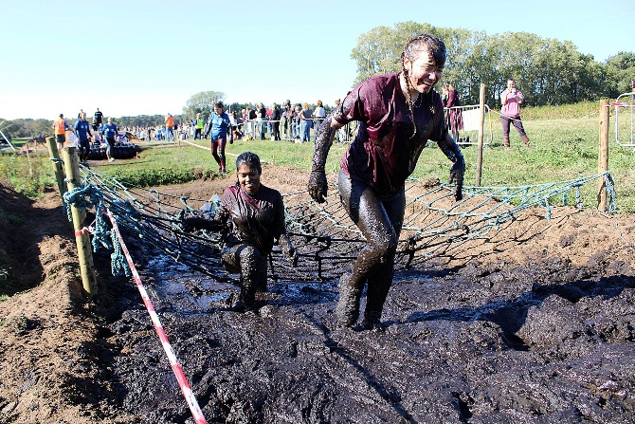
The Whole Hog
Date: Sunday 4th October 2026
Time: 7:30am – 3:30pm (approx.)
Location: Wantisden Valley, Wantisden Hall, Woodbridge, IP12 3PQ

Event details
The Whole Hog is a challenging trail running event set in beautiful countryside. Participants take on either a 5-mile or 8-mile off-road course through fields and woodland, with varied terrain and elevation.
Volunteer role
- Route Marshal – positioned around the 5- or 8-mile course to guide runners, monitor safety, and provide encouragement
Things to consider
This event takes place in open and exposed fields and woodland. It is fully outdoors, runs in all weather conditions, and involves a significant amount of standing and walking on uneven ground.

If you are interested in volunteering or would like to find out more, please contact info@suffolkmind.org.uk.
Thank you for supporting Suffolk Mind and helping us make a difference.

