

Ipswich Half Marathon 2026
Sunday 27th September

Thank you for your interest in volunteering with Suffolk Mind. Our fundraising events could not happen without the support of our amazing volunteers. Below you’ll find details of our annual Half Marathon event, what the day involves, and the volunteer roles available.
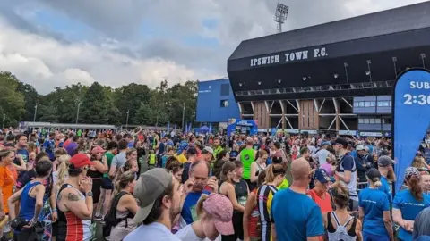
Ipswich Half Marathon
Date: Sunday 27th September 2026
Time: 8:00am – 1:30pm (approx.)
Location: Event village based at Ipswich Town Football Club, Portman Road, Ipswich. Volunteers will be positioned along the route throughout Ipswich.

Event details
The Ipswich Half Marathon is a large-scale road running event attracting hundreds of runners from across the region. Participants take on a 13.1-mile course through Ipswich, raising funds for Suffolk Mind and other local causes.
Volunteer role
- Route Marshal – directing runners, managing crossings, offering encouragement, and helping to keep participants and the public safe along the course
Things to consider
This is a fully outdoor event, will take place in all weather conditions, and involves a lot of standing.
If you are interested in volunteering or would like to find out more, please contact info@suffolkmind.org.uk.
Thank you for supporting Suffolk Mind and helping us make a difference.

