

Colour Rush 2026
Saturday 27th June

Thank you for your interest in volunteering with Suffolk Mind. Our fundraising events could not happen without the support of our amazing volunteers. Below you’ll find details of our annual Colour Rush event, what the day involves, and the volunteer roles available.
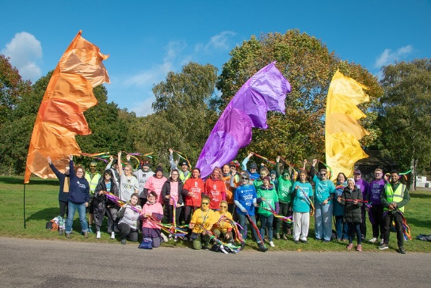
This event is outdoors and will go ahead in most weather conditions.
Volunteers should be comfortable standing for extended periods and interacting with members of the public.

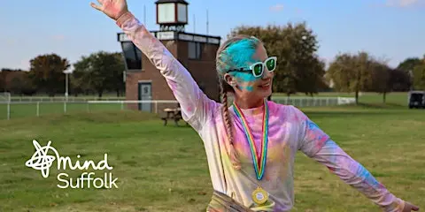
Date: Saturday 27th June
Time: 9:00am – 1:00pm (approx.)
Location: Venue 16, 312 Tuddenham Rd, Ipswich IP4 3QJ ·

Event details
Colour Rush is a fun, family-friendly sponsored run where participants walk, jog, or run a short course while being showered in brightly coloured powder at various stations along the route. The event village includes music, stalls, and a lively atmosphere celebrating physical activity and mental wellbeing.

Volunteer roles
- Car Park Attendants – guiding vehicles and helping ensure safe access to the site
- Event Village Helpers – supporting registration, welcoming participants, and general event support
- Merchandise Sales – selling Suffolk Mind merchandise and handling payments
- Route Marshals – guiding participants and ensuring the course is followed safely
- Colour Station / Paint Throwers – throwing colour powder and encouraging participants
Things to consider
This is a fully outdoor event, will take place in all weather conditions, and involves a lot of standing. Volunteers should be prepared to get colourful!
If you are interested in volunteering or would like to find out more, please contact info@suffolkmind.org.uk.
Thank you for supporting Suffolk Mind and helping us make a difference.

